Insert your name, centre number and candidate number into the header above.
Save this evidence document as evidence_ followed by your centre number_ candidate number. For example: evidence_ zz999_9999
Screenshots or program listings must be copied into appropriate cells in the following tables.
Examiners must be able to read the contents including any screenshots without the use of a magnifying glass. Answers that are not readable or missing will not be awarded any marks.
Save this evidence document at regular intervals, for example, every 10 minutes.
Question 1
Part 1(a)
class node:
def __init__(self, data, next_node):
self.data = data
self.nextNode = next_node

Part 1(b)
startPointer = 0
emptyList = 5
linkedList = [
node(1, 1),
node(5, 4),
node(6, 7),
node(7, -1),
node(2, 2),
node(0, 6),
node(0, 8),
node(56, 3),
node(0, 9),
node(0, -1),
]

Part 1(c)(i)
def outputNodes(linkedList, startPointer):
print(f"Outputting Nodes from {startPointer}")
while startPointer != -1:
print(linkedList[startPointer].data)
startPointer = linkedList[startPointer].nextNode

Part 1(c)(ii)
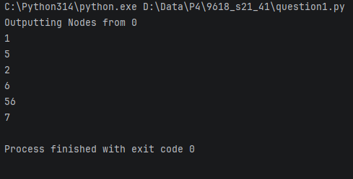

Part 1(d)(i)
def addNode(linkedList, startPointer, emptyList):
success = False
data = int(input("Enter data to add: "))
# Getting end of the list:
while startPointer != -1:
prevPointer = startPointer
startPointer = linkedList[startPointer].nextNode
while linkedList[emptyList].nextNode != -1:
# New Node:
linkedList[emptyList].data = data
linkedList[emptyList].nextNode = -1
# updating to join th new Node in linked list
linkedList[prevPointer].nextNode = emptyList
# Empty List updating
emptyList = linkedList[emptyList].nextNode
success = True
# Return true if inserted successfully
return success
# List is full as no space in emptyList
return success

Part 1(d)(ii)
def main():
outputNodes(linkedList, startPointer)
if addNode(linkedList, startPointer, emptyList):
print("Successfully added node")
else:
print("No space left to add node")
outputNodes(linkedList, startPointer)

Part 1(d)(iii)
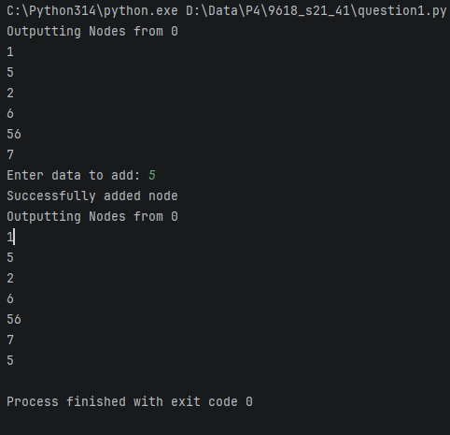

Question 2
Part 2(a)
arrayData = [10, 5, 6, 7, 1, 12, 13, 15, 21, 8]

Part 2(b)(i)
def linearSearch(search):
global arrayData
found = False
size = len(arrayData) - 1
for i in range(size):
if arrayData[i] == search:
found = True
# If not found, returns False
return found

Part 2(b)(ii)
def main():
search = int(input("Enter a number to search: "))
if linearSearch(search):
print(f"{search} is present in the list")
else:
print(f"{search} is not present in the list")

Part 2(b)(iii)
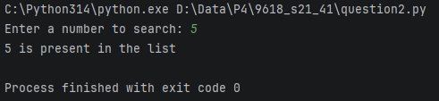

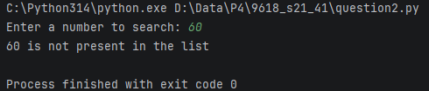

Part 2(c)
def bubbleSort():
global arrayData
size = len(arrayData)
for x in range(size):
for y in range(0, size):
if arrayData[y] > arrayData[y + 1]:
# swapping
temp = arrayData[y]
arrayData[y] = arrayData[y + 1]
arrayData[y + 1] = temp

Question 3
Part 3(a)
class TreasureChest:
def __init__(self, q, ans, points):
self.__question = q # String
self.__answer = ans # Integer
self.__points = points # Integer

Part 3(b)
arrayTreasure = [] * 4

def readData():
global arrayTreasure
questions = []
answers = []
points = []
try:
file = open(
"F:\\Data\\P4\\9618_s21_41\\9618_s21_sf_41\\06_9618_41_Confidential Source Files June 2021\\06_9618_41_Confidential Source Files June 2021\\TreasureChestData.txt",
"r",
)
except Exception as e:
print("Error: ", e)
else:
wholeFile = file.read().splitlines()
for i in range(0, len(wholeFile), 3):
questions.append(wholeFile[i])
# print(questions)
for i in range(1, len(wholeFile), 3):
answers.append(int(wholeFile[i]))
# print(answers)
for i in range(2, len(wholeFile), 3):
points.append(int(wholeFile[i]))
# print(points)

for i in range(len(questions)):
arrayTreasure.append(TreasureChest(questions[i], answers[i], points[i]))
# print(arrayTreasure.__question)

Part 3(c)(i)
def getQuestion(self):
return self.__question

Part 3(c)(ii)
def checkAnswer(self, ans):
return self.__answer == ans

Part 3(c)(iii)
def getPoints(self, numAttempt):
match numAttempt:
case 1:
return self.__points
case 2:
return self.__points // 2
case 3:
return self.__points // 4
case 4:
return self.__points // 4
case _:
return 0

Part 3(c)(iv)
def main():
readData()
numAttempt = 1
# question = readData()
qNum = int(input("Enter the question number between 1 and 5: "))
while qNum > 6 or qNum < 0:
qNum = int(input("Please Enter the question number between 1 and 5: "))
question = int(input(f"What is {arrayTreasure[qNum-1].getQuestion()}: "))
answer = arrayTreasure[qNum - 1].checkAnswer(question)
while not answer:
answer = arrayTreasure[qNum - 1].checkAnswer(
int(input("WRONG ANSWER! Re-Enter the answer of the question: "))
)
numAttempt += 1

print(f"Your Points: {arrayTreasure[qNum - 1].getPoints(numAttempt)}")

Part 3(c)(v)
